**Documentation**

**COVID-19 REPORT VACCINATION TREND ANALYSIS**

**Aim:-**This project aims to analyze data in detail on vaccinated and fully vaccinated people by year and country.

**Introduction:-**  
The main objective of this project is to analyze the data on, COVID-19 Vaccinations. We can find out some important insights by analyzing the data.

Step 1: Data cleaning  
I have used Power BI tool to clean and transform the data as per my understanding and I have replaced values, grouped the data and created a new table where it seemed fit.

Step 2: Data Visualization  
I have used Power BI tool to visualize the data available to gain meaningful insights and better understand the dataset. I have used different visualizations like bar graphs, line graphs which are available in the tool.

**Analysis:**

The dataset contains the following columns

* Country – The name of the countries (223 Countries in total)
* ISO Code – Code initials for the countries
* Date – The date, month and year of the data collected
* Total vaccinations – The total number of vaccinations administered which is nothing but the sum of the doses given on any particular date to the total vaccinations of the previous day.
* People vaccinated –. This is also an aggregated column meaning it is the sum of total of the previous day to the vaccinations of the present day.
* People fully vaccinated – The aggregated value of people who received the desired number of doses.
* Daily Vaccinations Raw – gives the raw data collected on vaccinations
* Daily vaccinations – The vaccinations administered on any particular day
* Total vaccinations per 100 – The total vaccinations administered per 100 people which also an aggregated data
* People vaccinated per 100 – The number of people who received at least one dose of vaccine, taking into account for every 100 people
* People fully vaccinated per 100 – For every 100 people how many are fully vaccinated
* Daily vaccinations per million – gives the number of vaccinations administered for every million population on any particular day.
* Vaccines – gives the different vaccines and their manufacturers separated by commas.
* Source name – gives the name of the source from which data is provided.
* Source website – gives the website link from where the data was obtained.

Now we know that what the data set contains to analysis the data.

The card visualization has been used to show different numeric values like total countries, vaccination details and number of people vaccinated.

* In this we can see that there are 223 countries available in the given data set

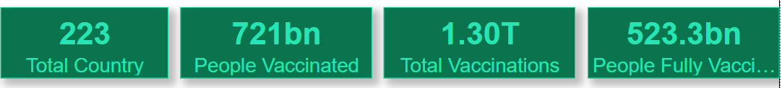

The Slicer is added with Year and the Month. It is used to know how the vaccine process is going on.



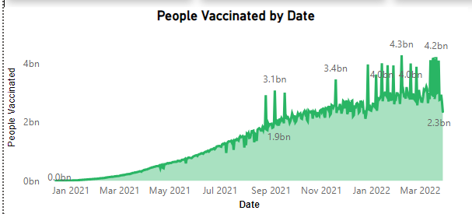

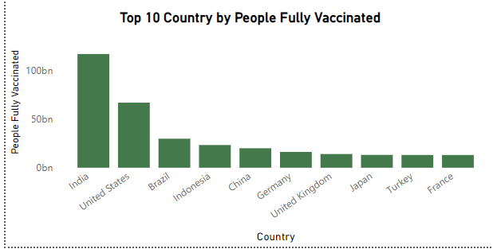

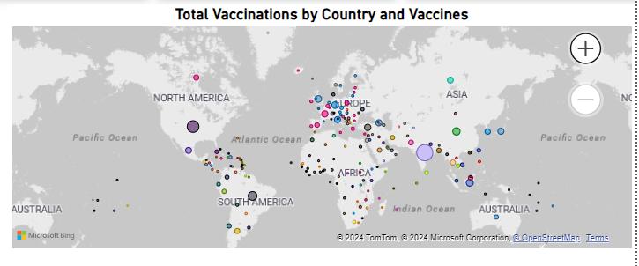

A map visualization is also shown which gives the Total vaccinated in different countries and are differentiated based on the colour gradient.

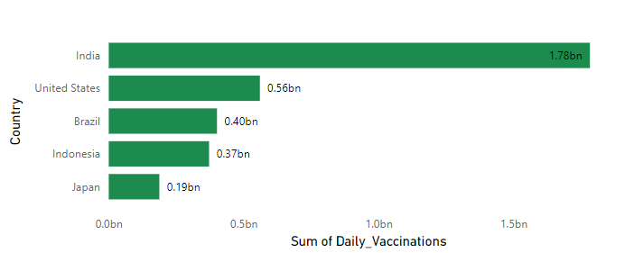

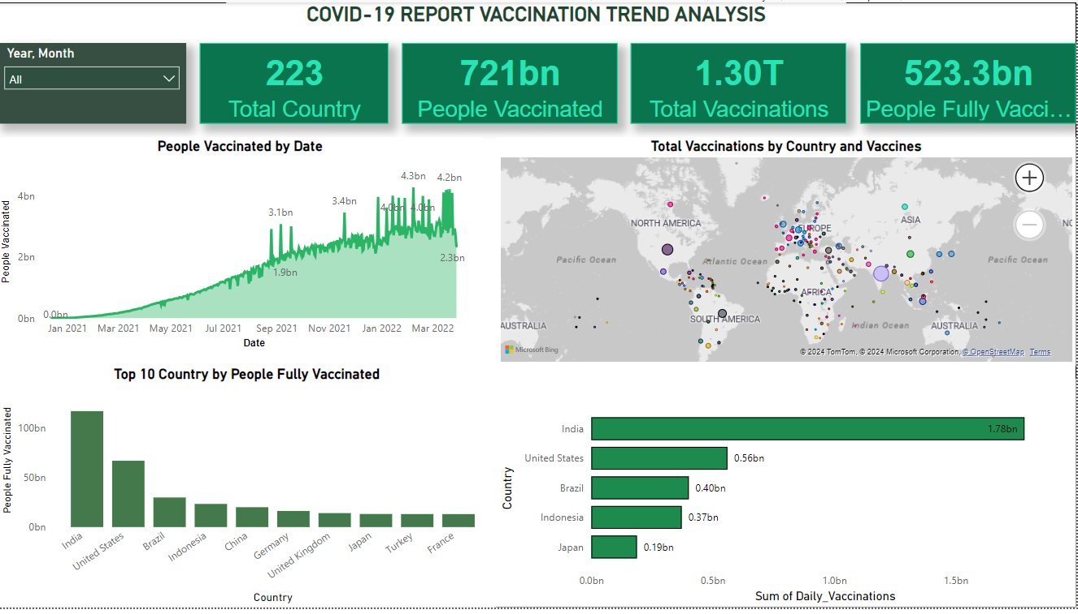

The final report provides valuable insights into the vaccination efforts around the world. By analyzing the data, it is possible to identify the top 10  countries with the highest rates of fully vaccinated individuals. The high rate of fully vaccinated showing that people are interested to destroy the deadly virus from the world.

**Conclusions:**

The results of this analysis reveal that the trend of COVID19 vaccinations is increasing in many countries.The data shows that the rate of vaccination varies across countries, with some countries having higher rates than others. In general, it appears that the rollout of the vaccine is progressing well, and that more people are becoming vaccinated on a daily basis.